SRJC Office of Veterans Affairs
Helpful Information for New Students

- Application
  - Complete your admission application.

- Orientation
  - Complete your online orientation which can be found in your student portal.
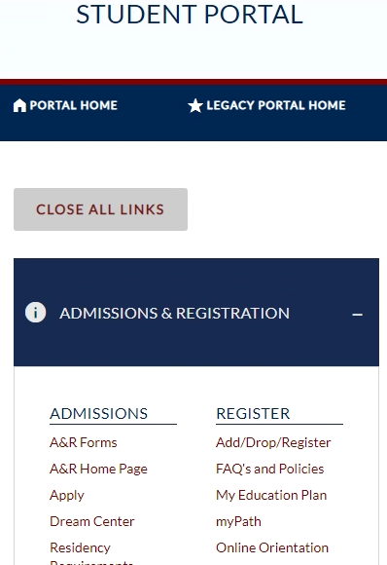

- Financial Aid
  - Apply for financial aid and scholarships.

- Assessment
  - Review your placement options for math and English.
  - Placement options vary depending on length of time since high school graduation.

- Counseling
  - Schedule an appointment to meet with a Veterans Academic Counselor by calling 707-527-4326.
  - At the time of your appointment, please be prepared to request official transcripts for any previous college coursework.

- Priority Registration – Veterans/Service Members Only
  - Apply for priority registration.

- Registration
  - Register for classes by logging into your student portal. Remember to reference your Education Plan when selecting your courses.
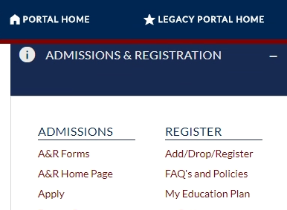
  - Once you have finalized your schedule, you must complete a Certification Request Form if you wish to use your VA educational benefit.
  - Please note, VA will only pay for courses required to complete your program of study.

- Student Success Appointment
  - Schedule an appointment to meet with the Veterans Student Success Specialist by calling 707-527-4326.

- Learning Supports
  - Learn more about whether you qualify for learning supports in the classroom setting by scheduling an appointment. To schedule your appointment, call 707-527-4326 or complete a Request for Services Form online.
    - Please note: Within the Request for Services form, there is a Medical Verification form that can be sent to your medical provider for completion, or you can upload a copy of your disability rating, if service connected.
  - Common learning supports: Extended time on exams, audiobooks, use of Smart Pen, strategies for concentration, memory and time management.

- Residency Status
  - Residency classification can be complex. If you see out of state tuition charges on your invoice, contact the SRJC Office of Veterans Affairs at 707-527-4326 for assistance with determining what options you might have.
  - Potential solutions for out of state tuition charges:
    - Military, Veteran, and Military Dependents Nonresident Tuition Exemption Request
    - Residency Reclassification Request Form
    - California Nonresident Tuition Exemption Request (AB 540)

- SRJC Veterans Affairs Request for Services and Statement of Understanding
  - As a new student, if you wish to access services through our office, we ask that you complete our Request for Services form.
    - This form will gather information that assists us in providing students with the best possible service.
  - As a new student, if you wish to use a VA educational benefit, we ask that you review our Statement of Understanding.

- Applying for VA Educational Benefits
  - Navigate to the U.S.D. Veterans Affairs website.
  - Under the Education block, select the link “Apply for education benefits”.
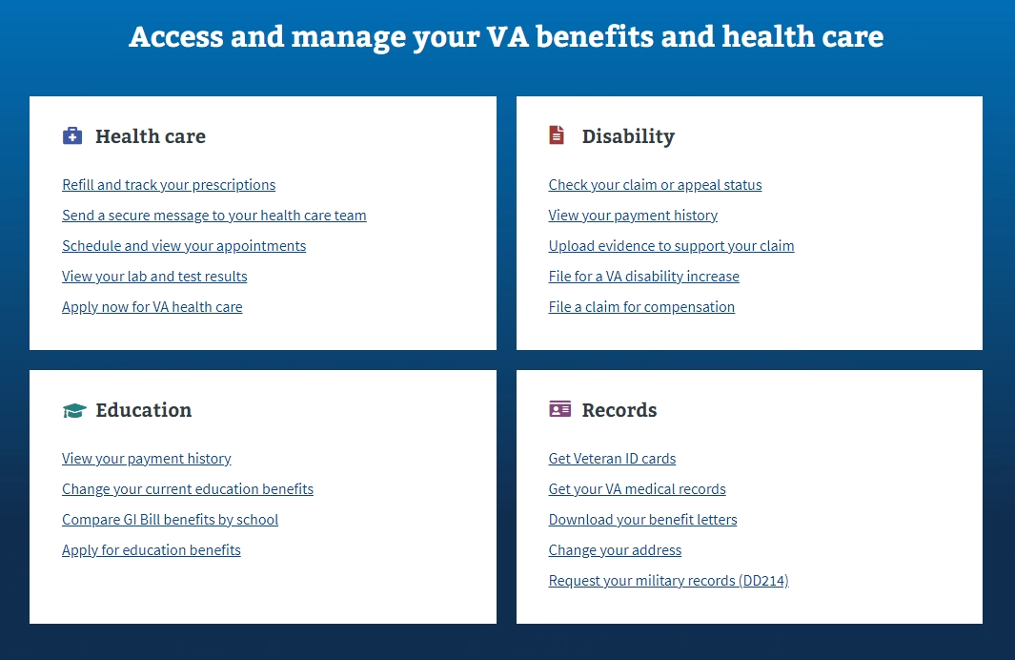

- Transcript Evaluation
  - If you have transcripts you would like to have evaluated for transfer credit, please have official transcripts sent to:
    - Admissions and Records
Santa Rosa Junior College
1501 Mendocino Ave
Santa Rosa, CA 95401

OR electronically to:
    - evaluations@santarosa.edu
  - Once transcripts have been received by SRJC, complete the Transfer Credit Evaluation Form.
    - Please note, Admissions & Records policy prohibits transcripts being evaluated for new students prior to registration for their first semester.

